CTCAcademy
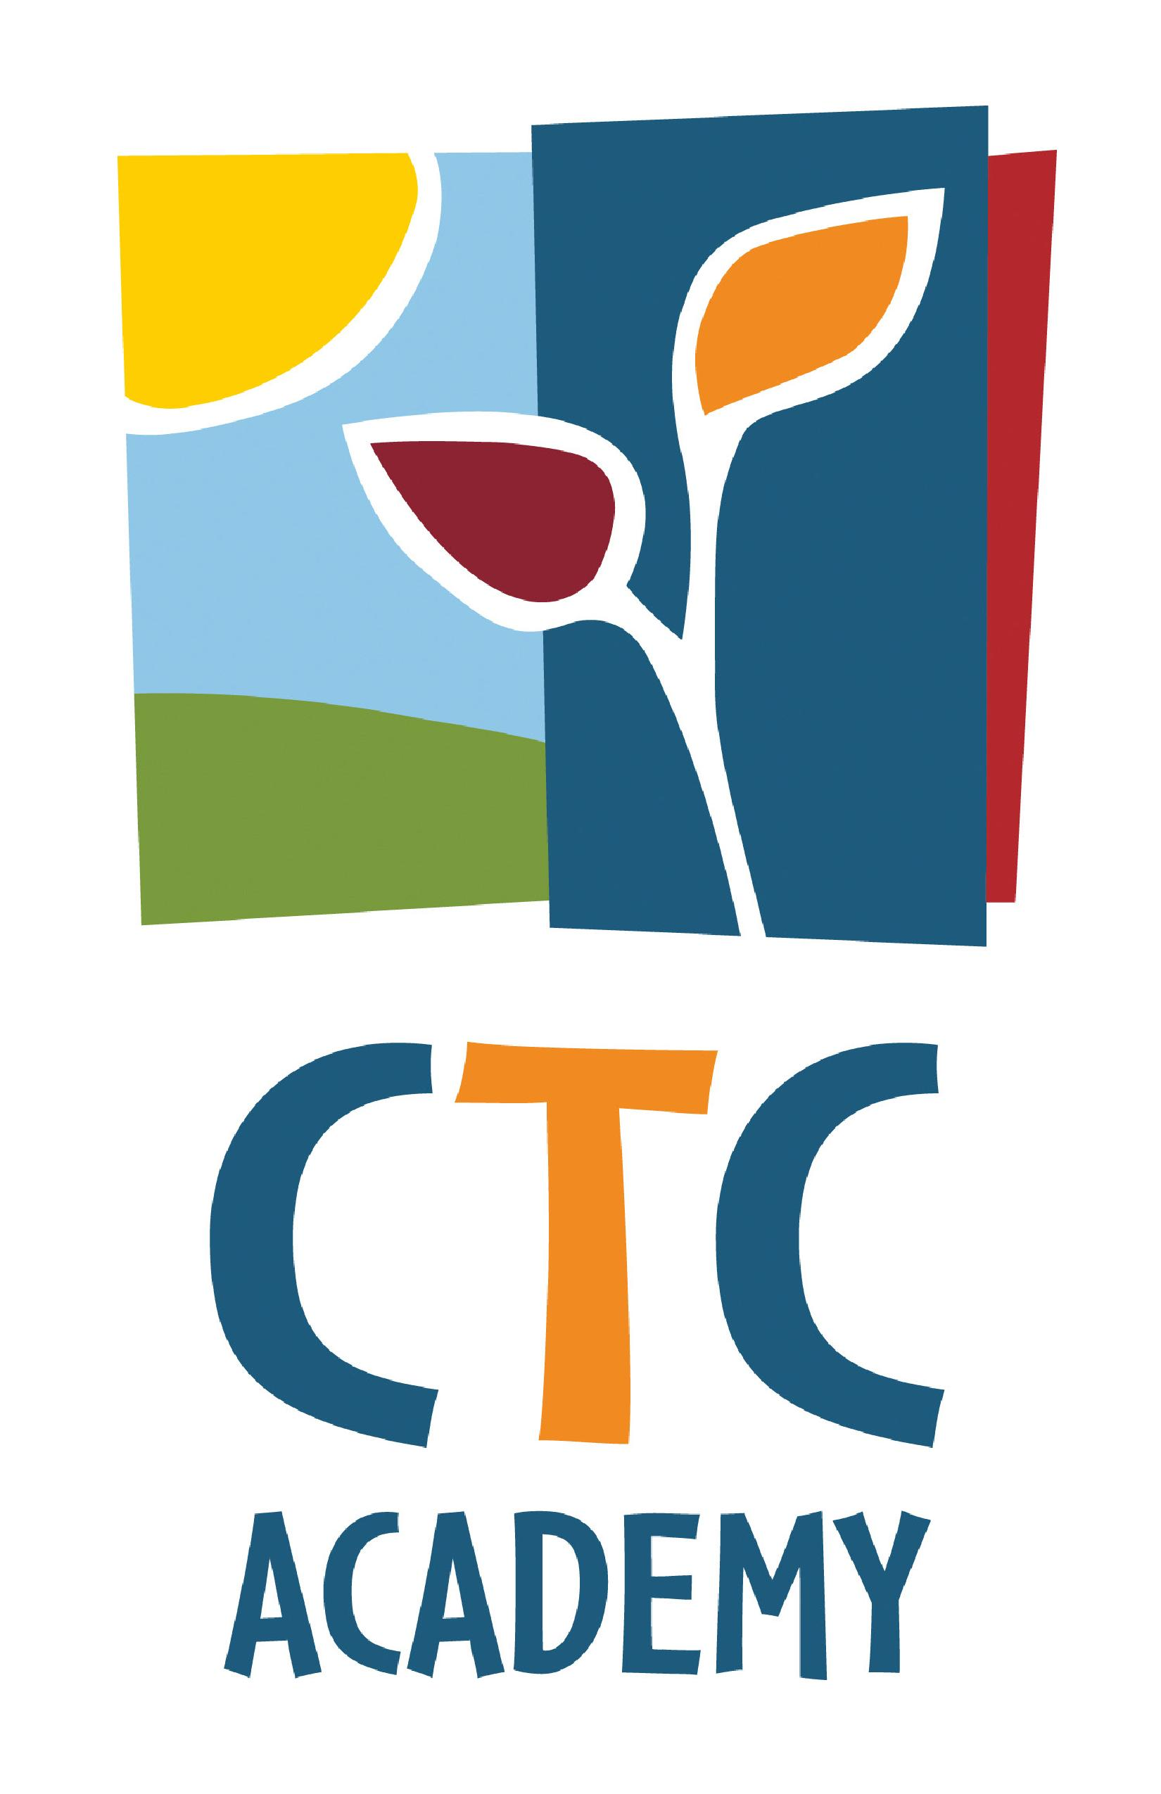
SchoolSpiritShoppingwith Lands’ End!

Step 1:Visit CTC Academy’s Lands’ End Shop

Step 2:Enter the requested Profile information and click Save School.
Order with a Friend!
Free shipping on $50+ orders!

Step 3: Sign in with your existing account or create a new account.

Step 4: Time to Shop!Select the age range you are shopping for in the left hand navigation bar. Then scroll down to select items to purchase.

Step 5:Be sure to select Logo Preference / CTC Academy Logo to ensure that our logo is embroidered on your clothing; Additional charge for logo is $5.50.

*IMPORTANT- many items are available in both children’s and adult’s sizes so please select sizing carefully

**Monogrammingis also available on your school spirit clothing order. Once your online order is complete, please contact Lands’ End at 1-800-469-2222 to
add monogram selection.

CLICK HERE TO START SHOPPING!
Please note that this is not a fundraiser…
Just a fun way for us to offer great CTC Academy spirit wear!

If you have any questions or issues with your order, please contact
Lisa Babin in Fair Lawn @ 201-797-7440 x3228
MarygraceLabosky in Oakland @ 201-612-5677 x2110
Lands’ End School @ 1-800-963-4816

